Class note CSE 3320

**Hardware components:**

* CPU
* Memory:
  + RAM: Larger (instruction and data)
  + ROM
  + Cache
  + Speed
  + Sizes
* Disks
  + SSD
  + Spinning (HDD)
* Peripherals:
  + Video Screens
  + KB
  + Sound
  + Printer
  + Network Interfaces

**Software:**

1. **Assembly- ARM assembly, x86**

Text file, in.asm

Ld ax, data

Inc ax

1. **Compile- C, Fortran**

In.c

If conditions DO:{}

in.,c->compiler->in.obj

1. **Interpret- Some basic language**
2. **Compile and Interpret- Java, Python**

* Application (API)
* Middleware (ABI)
* OS Kernel
* ROM drivers, Microcodes
* Only run when loaded in memory, usually not distinguishable. Good for manipulating code and data.

Change in performance SW

* Performance
* Easy to construct
* Memory USe

**OS Arch**

* Monolithic Kernel *Fast*
  + Entire OS (Driver, File System, and Application IPC) working in a Kernel Space, able to dynamically load/unload exe modules at runtime.
  + Both User Services and Kernel Services; kept in the same address space.
* BIOS Model
* MicroKernel
  + User and Kernel Services kept in different address space.

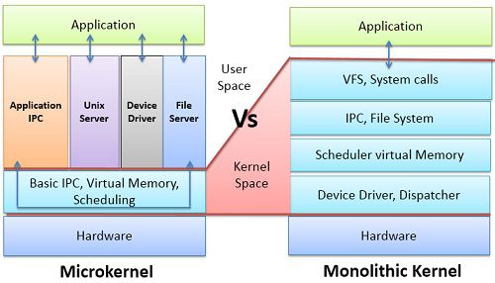

**First Assignment**